**COLLEGE OF BUSINESS EDUCATION**



**DODOMA CAMPUS**

***Course* : BACHELOR IN INFORMATION TECHNOLOGY**

***Lecturer* : ATUPELE CAIRO MWAITETE**

***Student name* : SIXTUS HESA KAZIMIRI**

***Reg no*. : 03.8263.01.02.2023**

***Subject* : PROGRAMMING IN JAVA**

***Nature of Work* : INDIVIDUAL ASSIGNMENT**

***Submission* : 28 JAN 2024**

**Question: You are required to create a small Java application that addresses an everyday challenge faced by individuals or communities in Tanzania with a theme of "Digital Solutions for Everyday Challenges in Tanzania". Each student should select a specific challenge and provide a software-based solution.**

**a)** **Promoting local culture (Swahili learning app)**

**THE REPORT OF JAVA PROGRAMMING CODE FOR SWAHILI LEARNING APP**

This report outlines the design, development, and implementation of the Swahili Learning App. The application aims to teach Swahili to beginners by providing interactive lessons, quizzes, and a vocabulary builder. Developed in Java, the app is designed for ease of use and scalability for future enhancements.

#### **Introduction**

* **Purpose:** To create an interactive application to promote Swahili learning for non-native speakers.
* **Scope:** The app includes vocabulary learning, grammar lessons, pronunciation guides, and quizzes for assessment.
* **Target Audience:** Beginners interested in learning Swahili, including students, travelers, and language enthusiasts.

#### **Objectives**

* Build a user-friendly Java application for Swahili learning.
* Incorporate features such as lesson modules, audio pronunciation, and real-time progress tracking.
* Ensure platform independence by leveraging Java's cross-platform capabilities.

#### **Project Design**

1. **System Architecture**
   * The app uses a modular architecture, separating UI, backend, and database components.
   * Designed to run on desktop environments using Java Swing for the user interface.
2. **Key Features**
   * **Lesson Modules:** Divided into vocabulary, grammar, and conversation practice.
   * **Quizzes:** Interactive multiple-choice quizzes to reinforce learning.
   * **Pronunciation Guide:** Audio clips for word and phrase pronunciation.
   * **Progress Tracker:** Tracks completed lessons and scores.
3. **Technology Stack**
   * Programming Language: Java
   * IDE: IntelliJ IDEA/Eclipse
   * Database: SQLite for lesson storage and user progress tracking
   * UI Framework: Java Swing or JavaFX
   * Audio: Java Sound API for pronunciation playback

**The General Overview of the program**

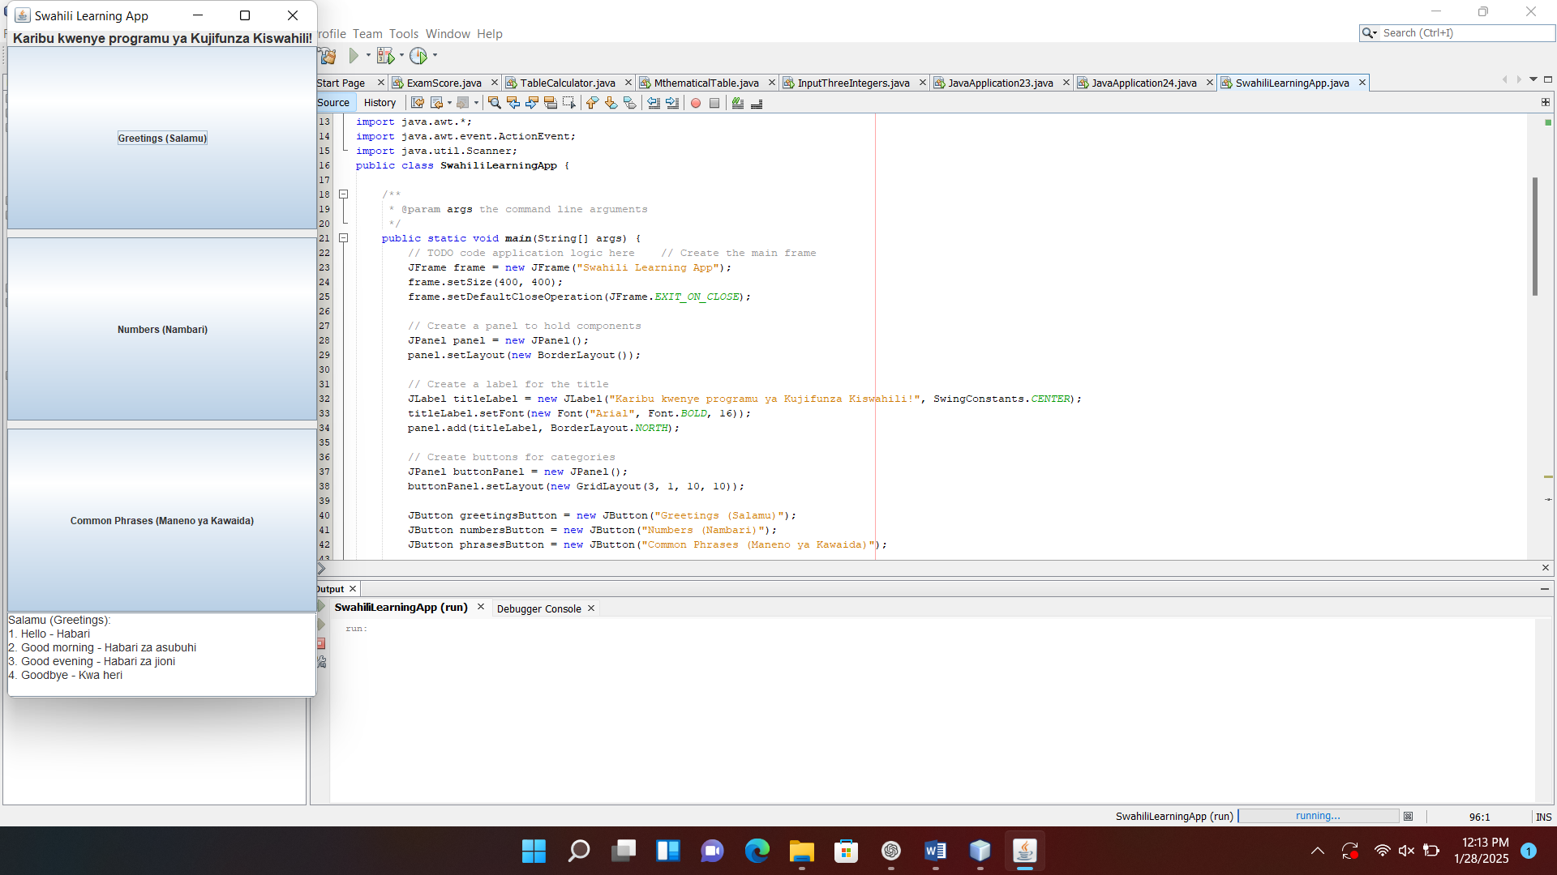

#### **Development Process**

1. **Planning:**
   * Conducted requirements analysis to define app features.
   * Created a project timeline with milestones for design, development, and testing.
2. **Implementation:**
   * **User Interface:** Built with Java Swing, featuring intuitive navigation and visually appealing layouts.
   * **Lesson Content:** Integrated lessons with topics like greetings, numbers, common phrases, and verbs.
   * **Database Integration:** Implemented SQLite for storing vocabulary and user progress.
   * **Audio Integration:** Used Java Sound API to load and play audio clips for pronunciation.
3. **Testing:**
   * Performed unit testing for individual modules.
   * Conducted user testing with feedback collected from beta users.
   * Fixed bugs and improved app responsiveness.

**When the code run here is the outcome showing the interface for the user to interact with the application (Swahili learning app)**

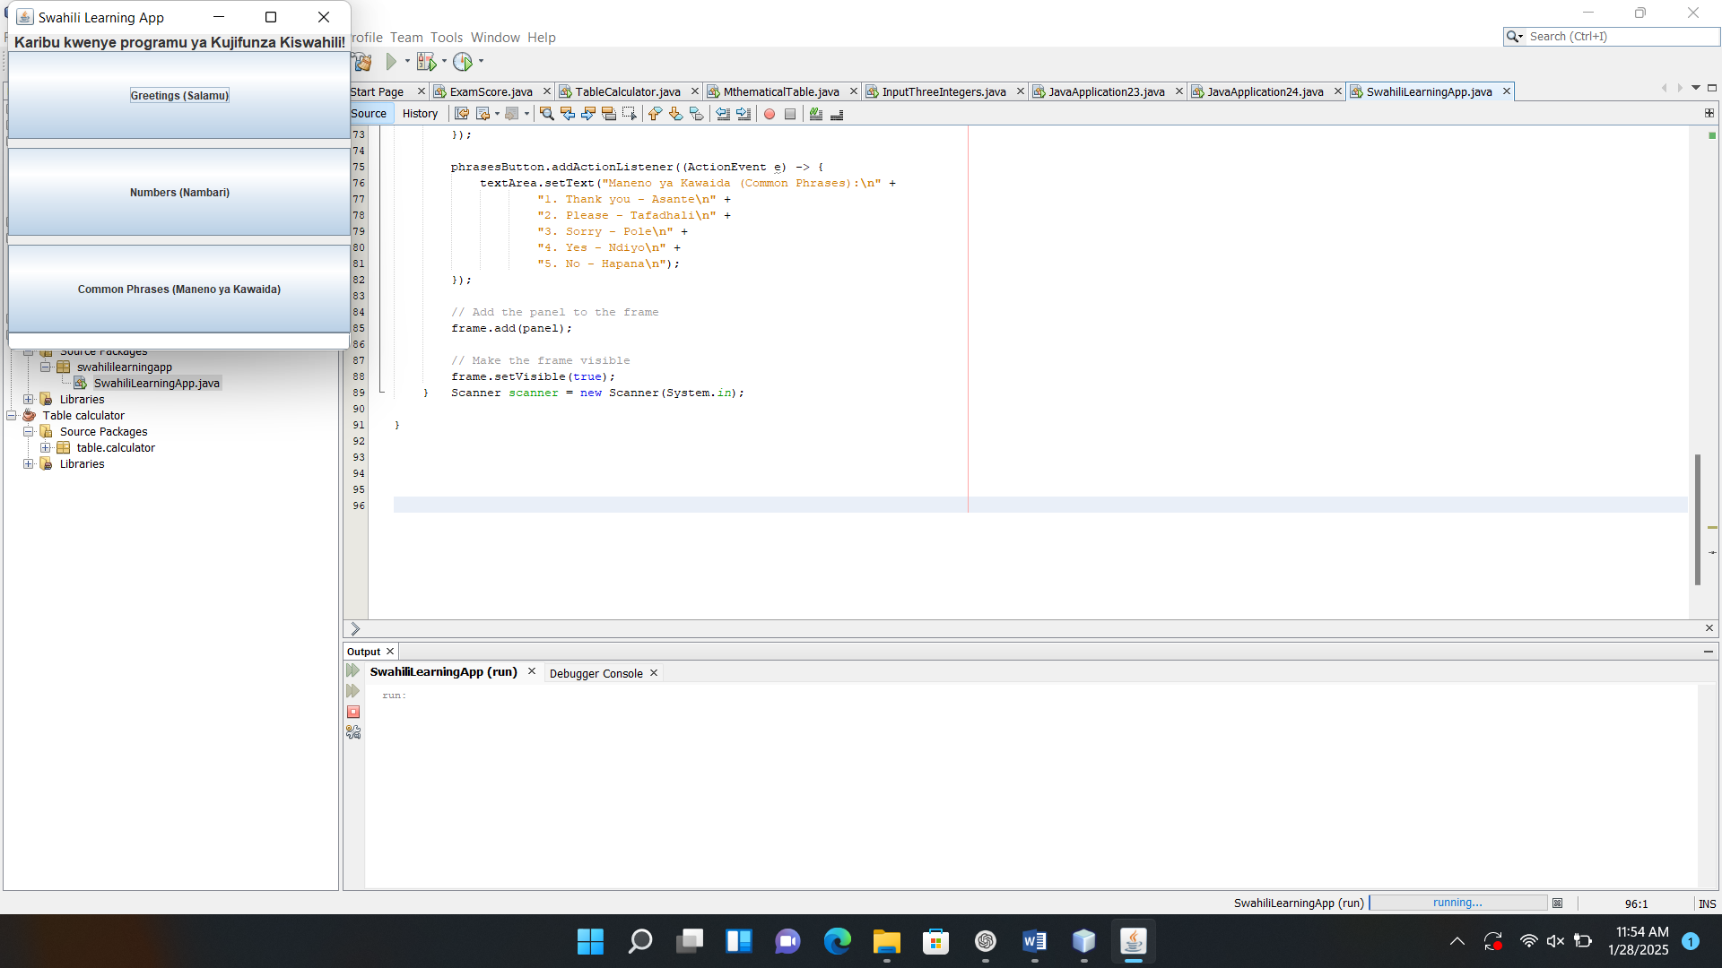

**Therefore the user is required to click the button in order to select among the three items which desire to learn including Greetings, Numbers or other Swahili phrases**

#### **Result**

#### The Swahili Learning App successfully meets its objectives by providing an engaging platform for learning Swahili. User feedback from the testing phase has been overwhelmingly positive, with suggestions for additional advanced lessons and cultural insights.

**When selecting the first button Greetings (Salamu) here is the outcome on the application**

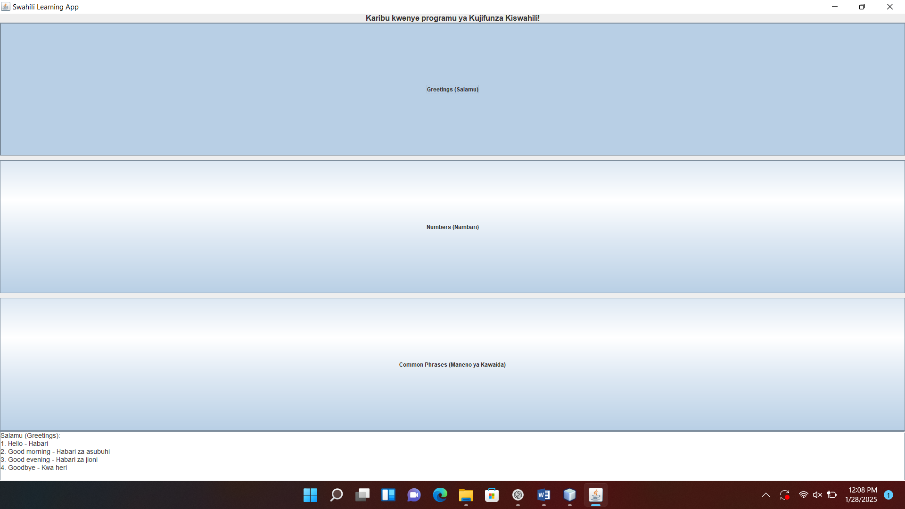

**When selecting the second button Number (Nambari) here is the outcome on the application**

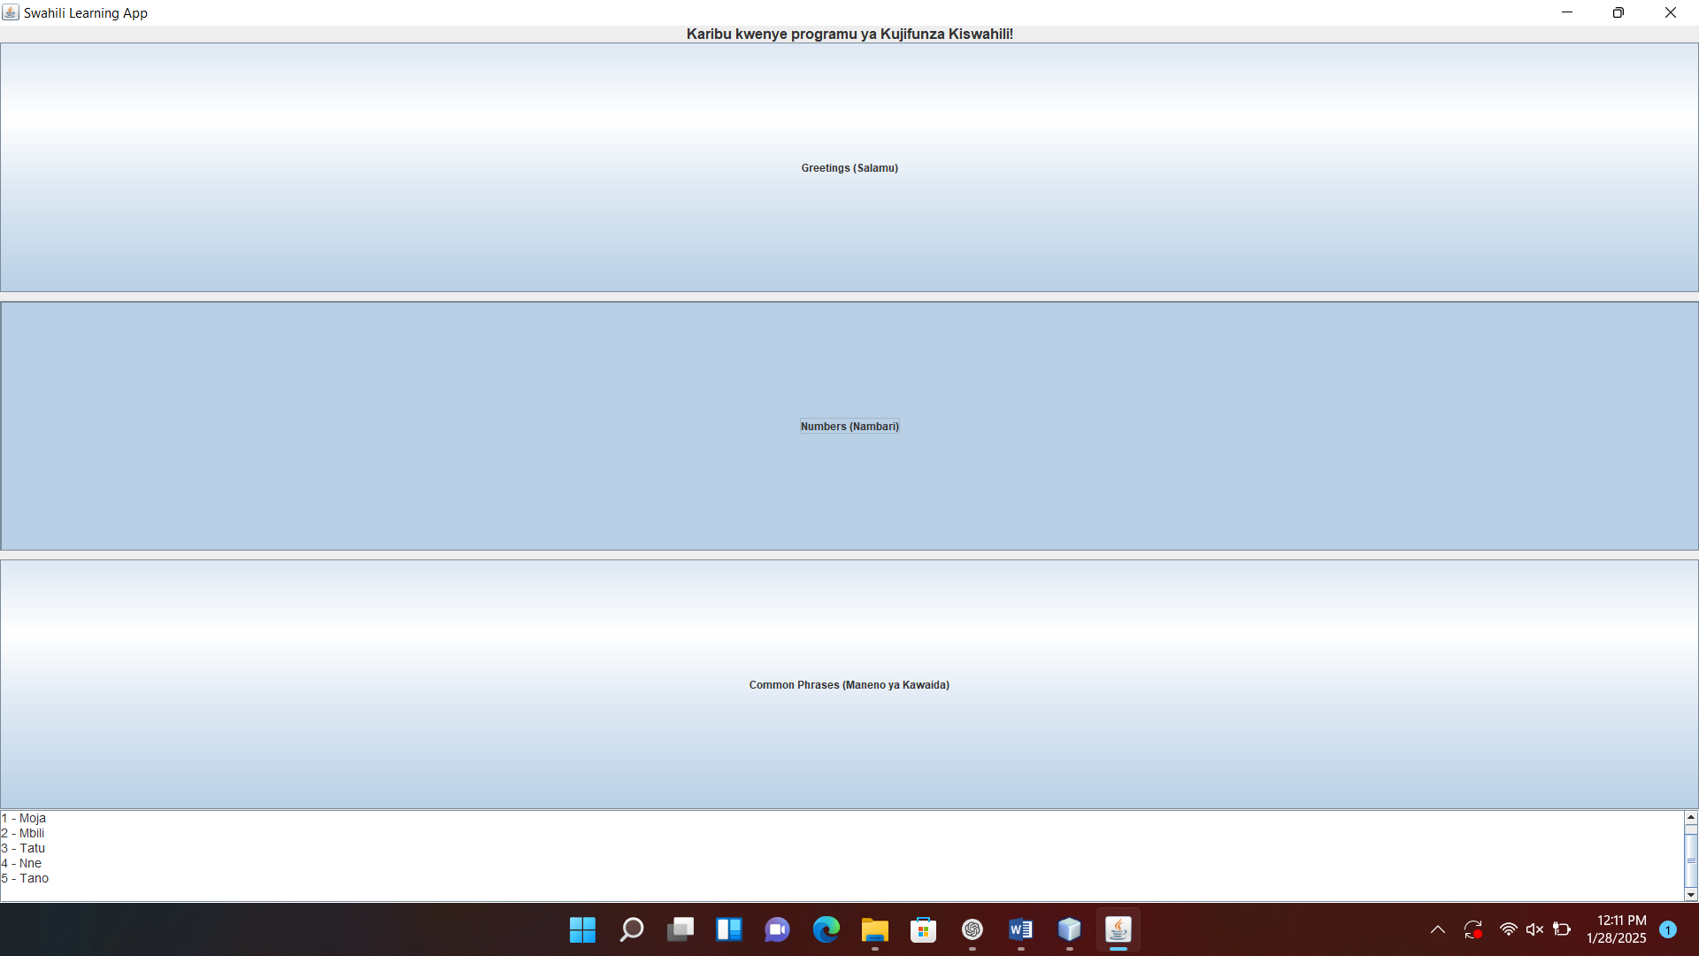

#### **Future Enhancements**

1. Mobile app version using Android SDK.
2. Addition of advanced grammar and conversational practice.
3. Gamification features, such as rewards and leaderboards.
4. Support for additional languages.
5. **Challenges when creating the Swahili learning application**
6. Expanding the app to include advanced features like quizzes, pronunciation audio, or multimedia content might be complex to implement.
7. Compiling a comprehensive and accurate Swahili learning dataset, especially for beginners.
8. Importing images to the project mainly the screenshots for the codes from NetBeans.

#### **Conclusion**

#### The Swahili Learning App is a functional and scalable application that provides users with an effective way to learn Swahili. The app demonstrates the versatility of Java for developing educational tools and has the potential to expand into a broader language learning platform.